On The Water

THE SCHUYLKILL RIVER

A SUITE OF ARCHIVAL DIGITAL PRINTS OF

J O U R N A L P A I N T I N G S

BY

J A M E S L A N C E L M c E L H I N N E Y

REVIVING A LOST ART

Inspired by expeditionary artists from Jacques le Moyne and John White to Seth Eastman and the brothers Kern, Delaware Valley native James Lancel McElhinney has revived the practice of journal-painting during trips to Europe, Hawaii, Ecuador, Peru, California, the Rocky Mountains, the American Southwest, the Hudson Valley, and now the Schuylkill River Fairmount Park.
Reviving practices employed by such traveler-artists as Benjamin Latrobe, William and Thomas Birch, Joshua Rowley Watson, Nicolino Calyo, James Lancel McElhinney now returns to Philadelphia to explore its Hidden River, call attention to its environmental priorities, explore its history and celebrate its beauty.
Works from the project O.T.W. The Schuylkill River will be featured in an exhibition at Independence Seaport Museum in Philadelphia, opening on October 24, 2018. The show will be on view for one year.

Following the examples of these late-18th and early 19th-century artists, McElhinney’s works have been reinterpreted as suites of prints, which can be enjoyed in the form of an unbound book, or framed for display on the wall.
O.T.W. The Schuylkill River, the limited edition, follows the success of McElhinney’s Hudson Highlands: North River Suite Volume One, which can be found in the following collections:
Avery Fine Art and Architecture Library, Columbia University
Boscobel House and Gardens, Garrison, New York
University of Denver. Library Special Collections. Denver Colorado
Hudson River Museum, Yonkers New York
Huntington Library and Museum, San Marino, California
West Point Museum, United States Military Academy
Yale Beinecke Rare Book and Manuscript Library. New Haven Connecticut
Newberry Library. Chicago, Illinois
And private collections in California, Colorado, Connecticut, Illinois, Massachusetts, New Jersey, New Mexico, New York, North Carolina and Pennsylvania.

PREVIEW

Needlewatcher Editions announces the forthcoming publication of O.T.W. The Schuylkill River, a suite of seven (7) numbered, signed and dated archival digital prints. Loosely bound in a fine cloth-covered Solander (clamshell) box, this suite of prints is accompanied by a descriptive chapbook. The edition is composed of 100% archival materials and limited to fifty (50) copies. Below is a selection of journal-paintings that may be included in the limited edition.

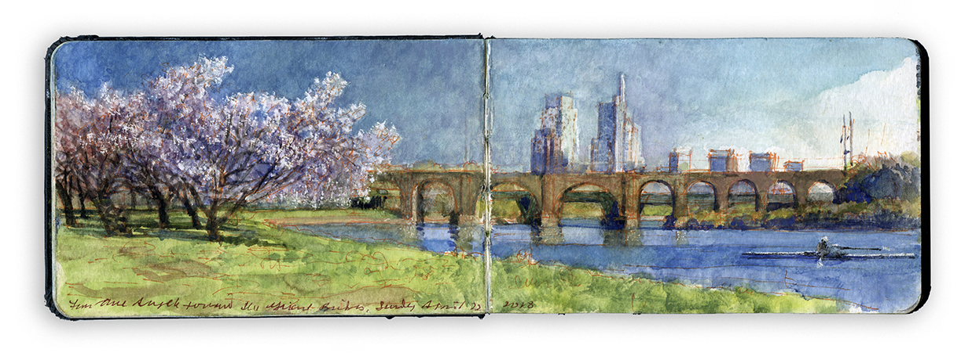

Girard Bridges from Three Angels. Aqueous media on paper. Sketchbook 3.5 x 10”

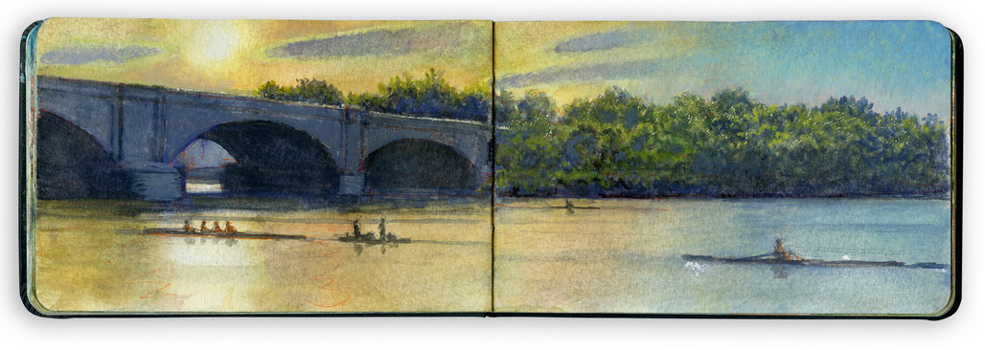

Sunset. Columbia Bridge. Aqueous media on paper. Sketchbook 3.5 x 10”

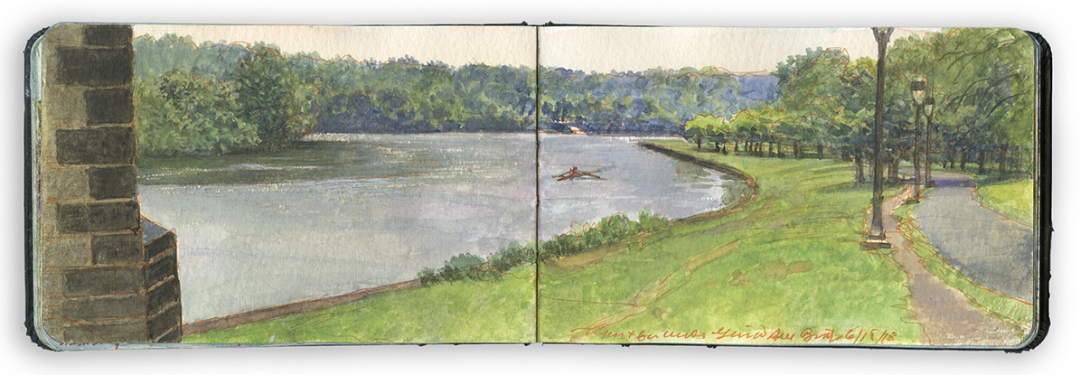

North from Below the Pennsylvania Railroad Connecting-Bridge. Aqueous media on paper. Sketchbook 3.5 x 10

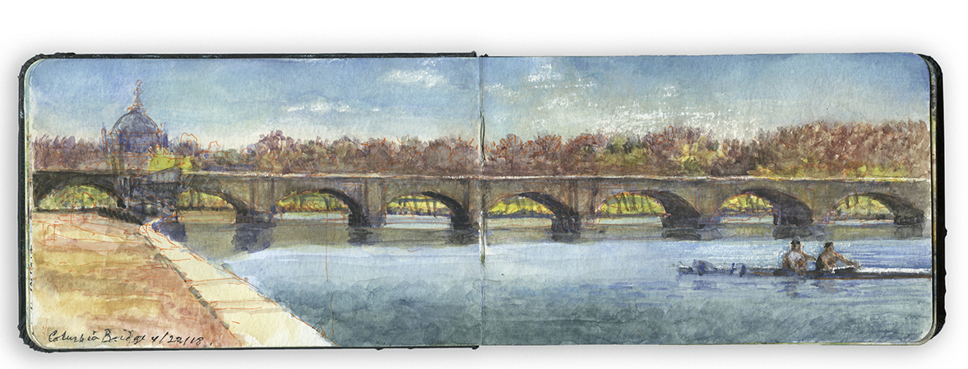

A Double Approaching Columbia Bridge. Aqueous media on paper. Sketchbook 3.5 x 10”

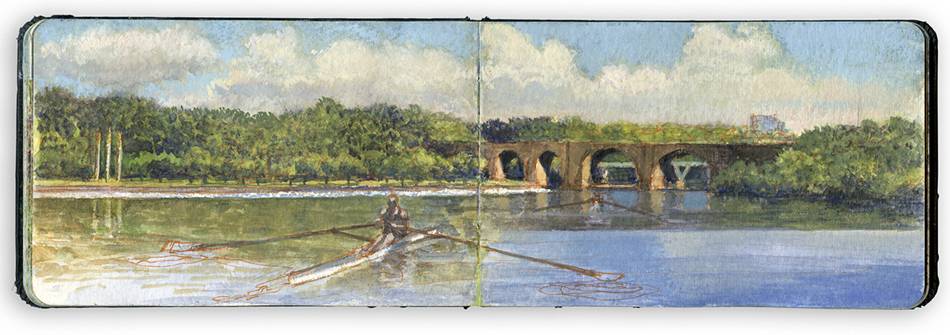

Lone Oarsman Passing Three Angels. Aqueous media on paper. Sketchbook 3.5 x 10”

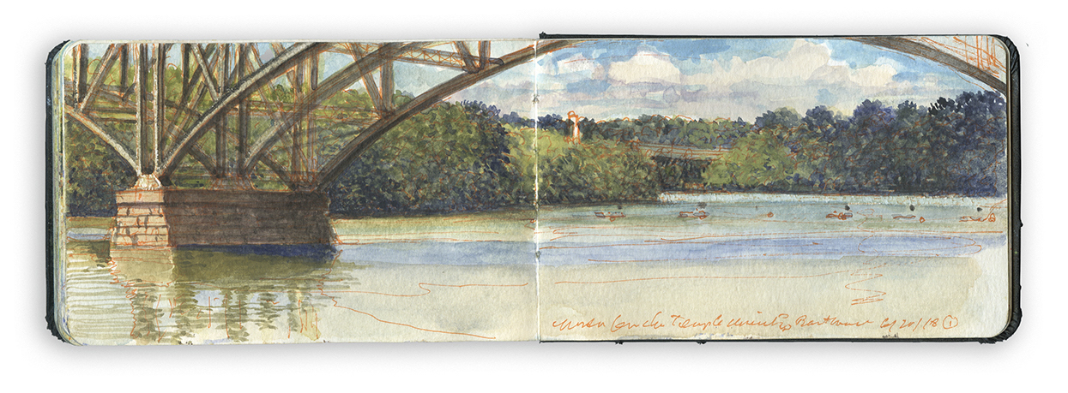
North from Temple Boathouse. Aqueous media on paper. Sketchbook 3.5 x 10”
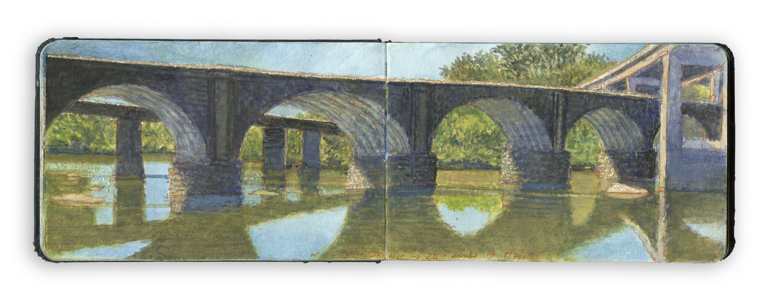
Twin Stone Bridges, East Falls. Aqueous media on paper. Sketchbook 3.5 x 10”

You are invited to support this project with a subscription to the deluxe limited edition at $1200.00 per copy.
Subscribers who pledge prior to October 8, 2018 will be thanked in the limited edition, and acknowledged in the exhibition at Independence Seaport Museum, opening on October 24, 2018. The show will remain on view for one year.
On October 25 2018 (the official release date) remaining copies of the limited edition will be offered with tiered pricing, starting at $1,600.00 per copy. Personal check, PayPal and credit cards are accepted by Needlewatcher Editions. For further details, or to reserve a copy, please enquire at otw@needlewatcher.com, or call 347-266-5652

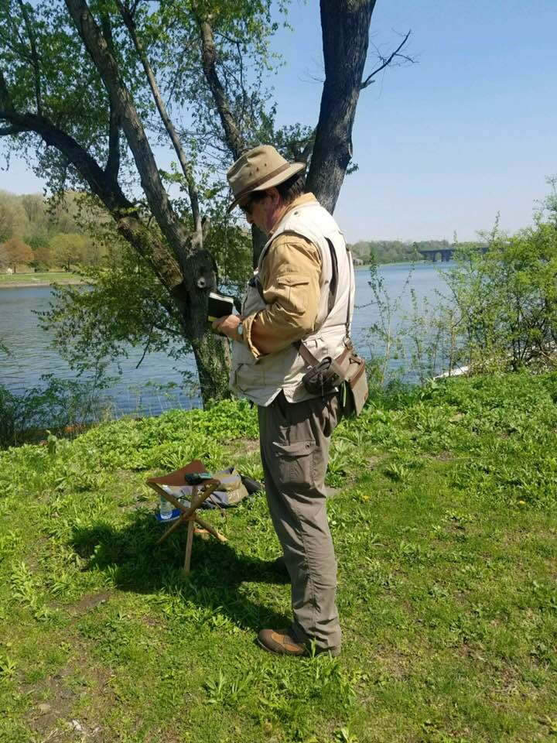
James Lancel McElhinney working along the Schuylkill in May, 2018

James Lancel McElhinney is a visual artist, author, historian and publisher, known for his depictions of American rivers and battlefields. The Delaware Valley native attended Tyler School of Art, Skowhegan School of Painting and Sculpture and Yale.
He is a recipient of a 2017 Pollock-Krasner Grant., and an artist fellowship from the National Endowment for the Arts.
McElhinney is listed on the Master Artist Council of the Arthur Miller Foundation. O.T.W: The Schuylkill River will be on view from October 24, 2018, at Independence Seaport Museum, as the inaugural exhibition in a contemporary art-space complementing the museum’s new River Alive galleries. McElhinney lives in Manhattan with his wife, historian, author and curator Dr. Katherine Manthorne, and a feline named Maeve. His website is www.mcelhinneyart.com

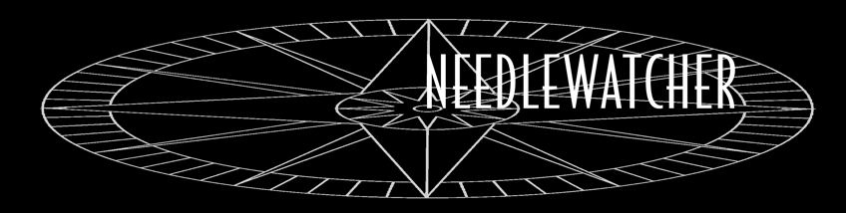

EDITIONS@NEEDLEWATCHER.COM PO Box 142. West Haverstraw NY 10993

Needlewatcher Editions editions@needlewatcher.com

O.T.W. The Schuylkill River
By James Lancel McElhinney © 2018
A Limited-Edition of Fifty
Release date: October 25, 2018

Contents: This product can be enjoyed as a loose-bound book, or individual prints can be framed for wall display
- Seven Archival Digital Prints, signed, dated, numbered
- Companion chapbook
- Colophon page with index of images
- Fine cloth-covered Solander (clamshell) box with debossed cover and spine

Order: Number of copies ______ count. Limit three (3) copies per order.
Name: _____________________________________________________________________

Street address: ______________________________________________________________

City: _______________________________________________________________________

State: ____________________________________ Zip code___________________________

Country: ________________________________________

Pre-publication price: $1,200.00 USD (Through October 25, 2018)
Retail price: $1,600.00 USD (Starting October 26, 2018, with tiered pricing)
(New York State residents add 8% sales tax)
Multiple copies: [ ] One copy: $1200.00 [ ] Two copies: $2200.00 [ ] Three copies: $3000.00

Individuals who complete their purchase prior to October 8, 2018 will be thanked, and listed on the Acknowledgements page of the companion chapbook. Order will be filled starting October 29, 2018. Allow two weeks for delivery.
For enquiries, or to reserve a copy, please email editions@needlewatcher.com (subject line “Prints”)
To purchase:
[ ] Bill me. Copy/copies will be shipped when payment is received.
[ ] Check is enclosed. Please make your check payable to Needlewatcher LLC.
[ ] PayPal: Send payment to editions@needlewatcher.com

To pay by credit card: Cardholder_____________________________________________________

Associated address________________________________________________

Card # ________________________________________________________

Expiration date: ____/_____ Security Code____________

Please return with this form to Needlewatcher Editions, PO Box 142, West Haverstraw, New York, 10993

